- Setup ARGO CD
- Create Jenkins job for CI.
- Create Jenkins job to create docker image and build image.
- Create ArgoCD job to deploy on ek8s cluster.

Task 1 — Setup Argo CD on EKS

Objective
Install Argo CD on the EKS cluster and access its web UI. This will later allow Argo CD to continuously monitor the GitOps repository and deploy applications to EKS.

Architecture
GitHub
|
| Kubernetes manifests
v
+-----------+
| Argo CD |
| in EKS |
+-----------+
|
| Sync
v
+---------------+
| EKS Cluster |
| |
| Deployment |
| ↓ |
| Pods |
+---------------+

Prerequisites
Use your existing EKS cluster or create a new cluster:
aws eks update-kubeconfig \
--region us-east-1 \
--name eksctl-demo
Verify:
kubectl get nodes
Expected:
NAME STATUS ROLES AGE VERSION
... Ready <none> ... ...
... Ready <none> ... ...

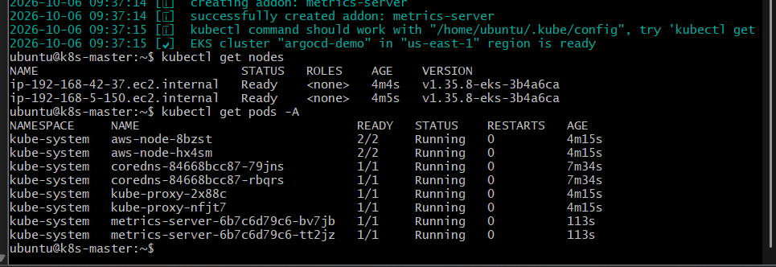

1. Create Argo CD namespace
kubectl create namespace argocd
Verify:
kubectl get namespace argocd
Expected:
NAME STATUS
argocd Active
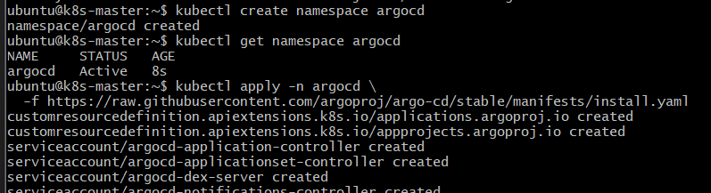

2. Install Argo CD
Run:
kubectl apply -n argocd \
-f https://raw.githubusercontent.com/argoproj/argo-cd/stable/manifests/install.yaml
This creates the Argo CD components inside the argocd namespace.

3. Verify Argo CD pods
kubectl get pods -n argocd
Initially, some pods may show:
ContainerCreating
Wait until they become:
Running
You should see components such as:
argocd-application-controller
argocd-dex-server
argocd-notifications-controller
argocd-redis
argocd-repo-server
argocd-server
argocd-applicationset-controller
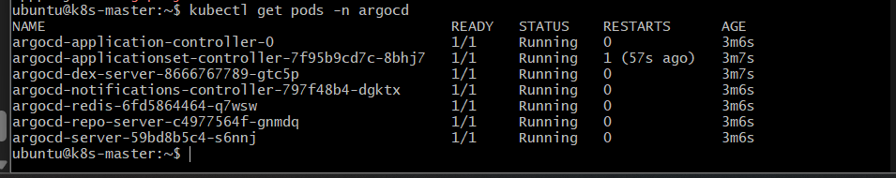
You can also check:
kubectl get all -n argocd

4. Check Argo CD services
kubectl get svc -n argocd
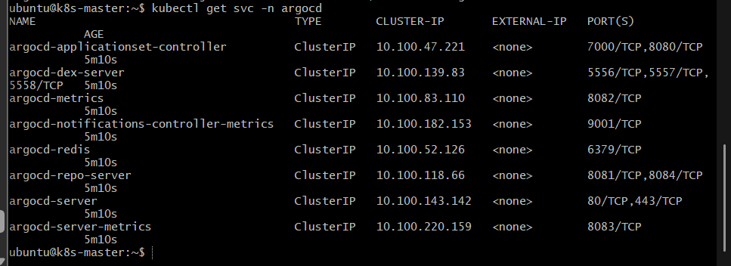
You should see:
argocd-server
argocd-repo-server
argocd-redis
...
By default, argocd-server is a ClusterIP.
For our lab, we'll temporarily expose it using port forwarding.

5. Access Argo CD UI
Run:
kubectl port-forward svc/argocd-server -n argocd 8080:443
You should get:
Forwarding from 127.0.0.1:8080 -> 443
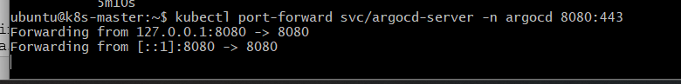
Keep this terminal running.
Then open your browser:
https://localhost:8080
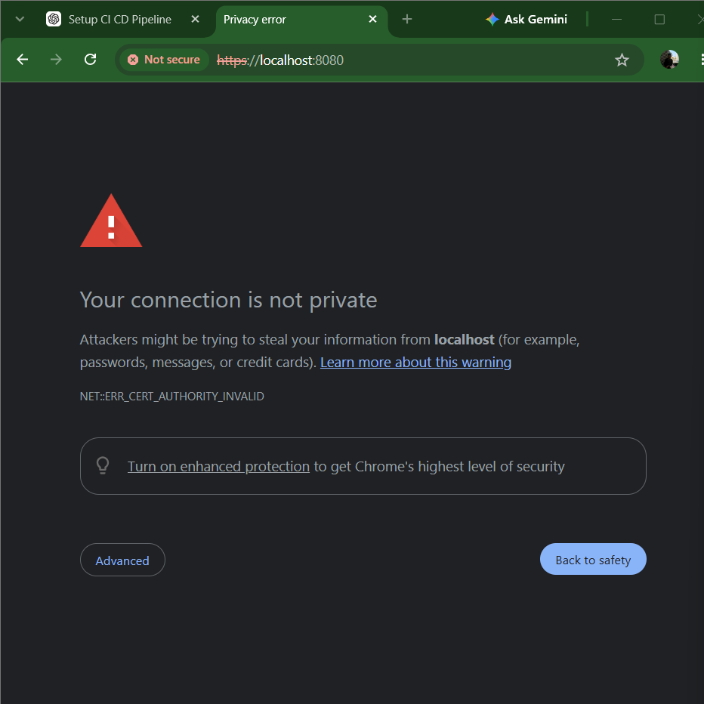
You may receive a browser certificate warning because Argo CD uses a self-signed certificate initially.
Choose Advanced → Proceed.

6. Get Argo CD admin password
Open another terminal.
Run:
kubectl -n argocd get secret argocd-initial-admin-secret \
-o jsonpath="{.data.password}" | base64 -d
Copy the displayed password.
Login:
Username: admin
Password: <password from above>
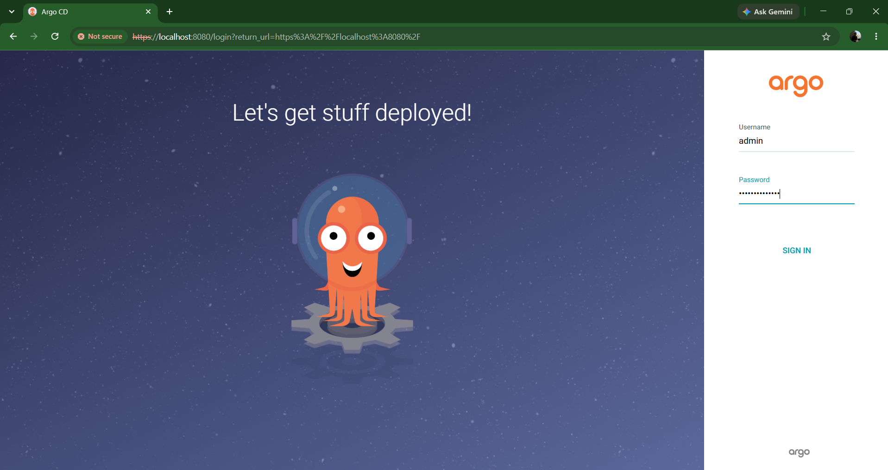

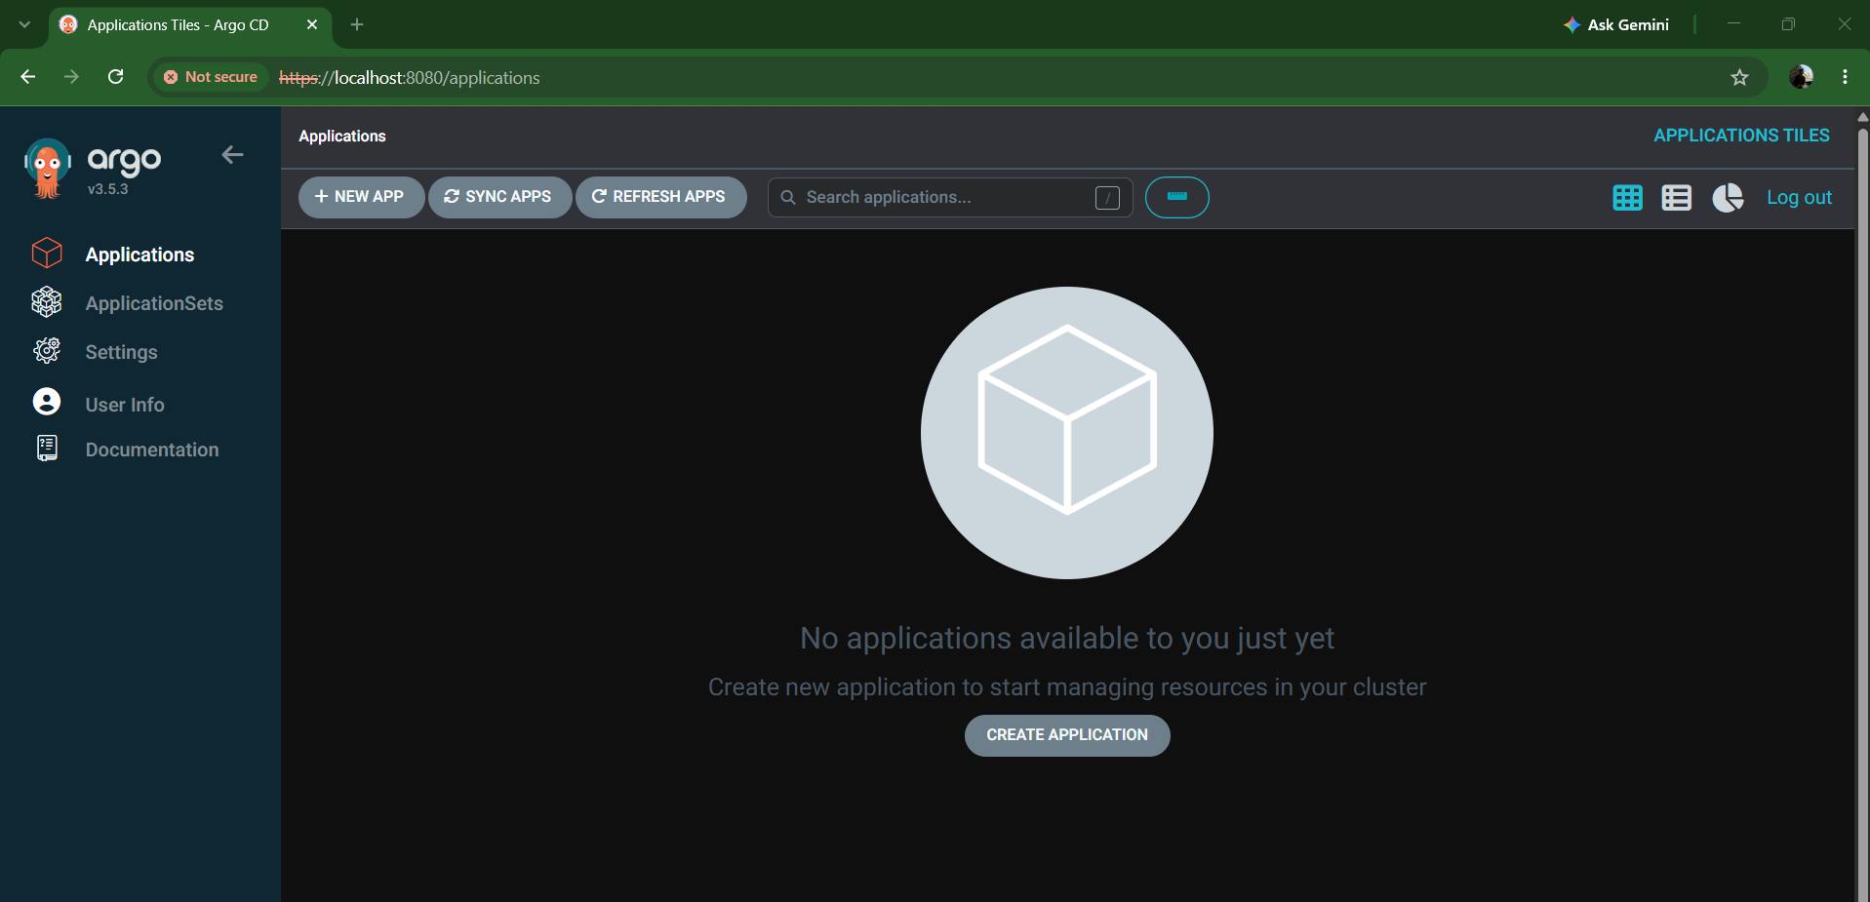

7. Install Argo CD CLI
On your Ubuntu EC2/Jenkins administration machine, check:
argocd version --client
If it is not installed, install it with:
curl -sSL -o argocd-linux-amd64 \
https://github.com/argoproj/argo-cd/releases/latest/download/argocd-linux-amd64
sudo install -m 555 argocd-linux-amd64 /usr/local/bin/argocd
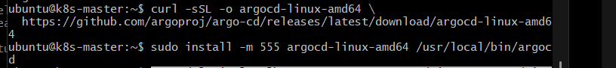
Verify:
argocd version --client

8. Login using Argo CD CLI
Because we are using port forwarding:
argocd login localhost:8080 --username admin --password '<PASSWORD>' --insecure
Replace <PASSWORD> with the password retrieved earlier.
Verify:
argocd account get-user-info
Expected:
Logged In: true
Username: admin
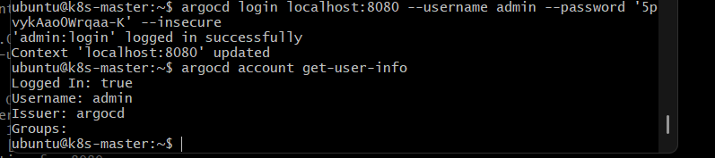

9. Verify Argo CD
Run:
argocd app list
Initially, you should see no applications:
NAME CLUSTER NAMESPACE PROJECT STATUS
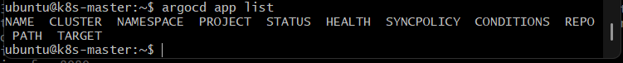
That's expected.
At this point:
EKS
|
+---------------+
| Argo CD |
| |
| Server |
| Repo Server |
| Controller |
| Redis |
+---------------+
|
|
No Applications

Outcome
Task 1 is complete when:
- Argo CD namespace exists.
- Argo CD pods are Running.
- Argo CD server is accessible.
- You can log in as admin.
- argocd app list works.

Task 2 — Create Jenkins CI Job

Objective
Create a Jenkins CI pipeline that automatically:
GitHub
|
| Clone source code
↓
Jenkins
|
├── Build
├── Test
└── Archive/verify artifact

2.1 Prerequisites
Before creating the job, we need to know which application repository you want Jenkins to build.
For this lab, I recommend using your existing Java/Maven application repository if you still want to use it.
On the Jenkins server, verify:
java -version
mvn -version
git --version
You should have:
Java 17/21
Maven 3.x
Git
Also verify Jenkins is running:
sudo systemctl status jenkins

2.2 Create Jenkins Pipeline Job
Open Jenkins:
http://<JENKINS-IP>:8081
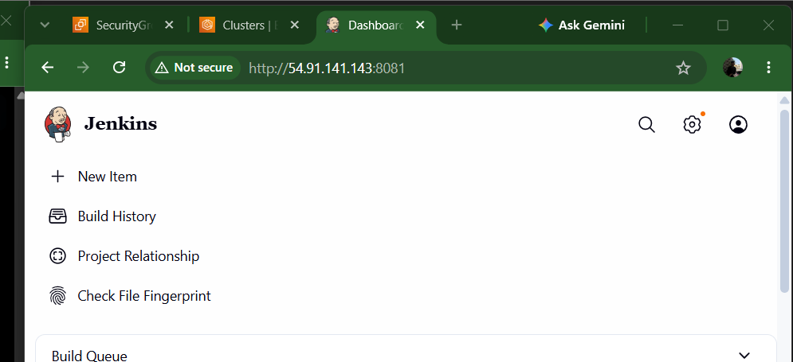
Go to:
New Item
↓
Enter item name:
jenkins-ci
↓
Pipeline
↓
OK
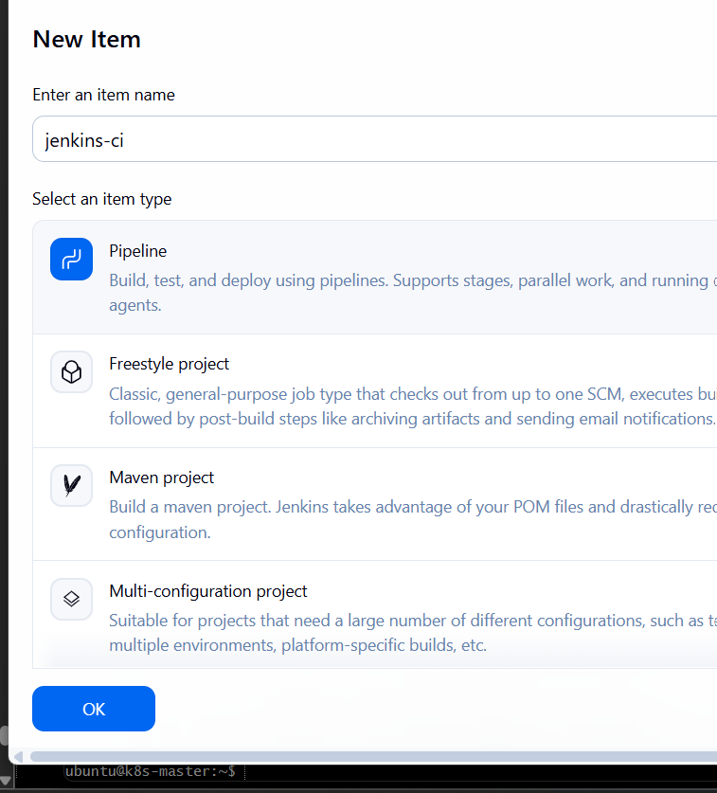

2.3 Configure the Pipeline
Scroll down to Pipeline.
Select:
Definition:
Pipeline script
For the first CI exercise, we'll put the Jenkinsfile directly into Jenkins.
Use this pipeline:
pipeline {

agent any

tools {
maven 'Maven-3.8.4'
}

stages {

stage('Git Clone') {
steps {
git branch: 'main',
url: 'https://github.com/YOUR-USERNAME/YOUR-REPOSITORY.git'
}
}

stage('Build') {
steps {
sh 'mvn clean compile'
}
}

stage('Test') {
steps {
sh 'mvn test'
}
}

stage('Package') {
steps {
sh 'mvn package -DskipTests'
}
}

}

post {

success {
echo 'CI Pipeline completed successfully.'
}

failure {
echo 'CI Pipeline failed.'
}

always {
echo 'CI Pipeline execution completed.'
}
}
}

Replace this
https://github.com/YOUR-USERNAME/YOUR-REPOSITORY.git
with your actual application repository.
For example:
git branch: 'main',
url: 'https://github.com/example/java-app.git'

So the actual one is

pipeline {
agent any

tools {
maven 'Maven-3.8.4'
}

stages {

stage('Git Clone') {
steps {
echo 'Cloning source code from GitHub...'

git branch: 'main',
url: 'https://github.com/Nikhilreddy0549/devops-cicd-demo.git'
}
}

stage('Build') {
steps {
echo 'Compiling the application...'
sh 'mvn clean compile'
}
}

stage('Test') {
steps {
echo 'Running unit tests...'
sh 'mvn test'
}
}

stage('Package') {
steps {
echo 'Creating JAR package...'
sh 'mvn package -DskipTests'
}
}
}

post {
success {
echo 'CI Pipeline completed successfully.'
}

failure {
echo 'CI Pipeline failed.'
}

always {
echo 'CI Pipeline execution completed.'
}
}
}

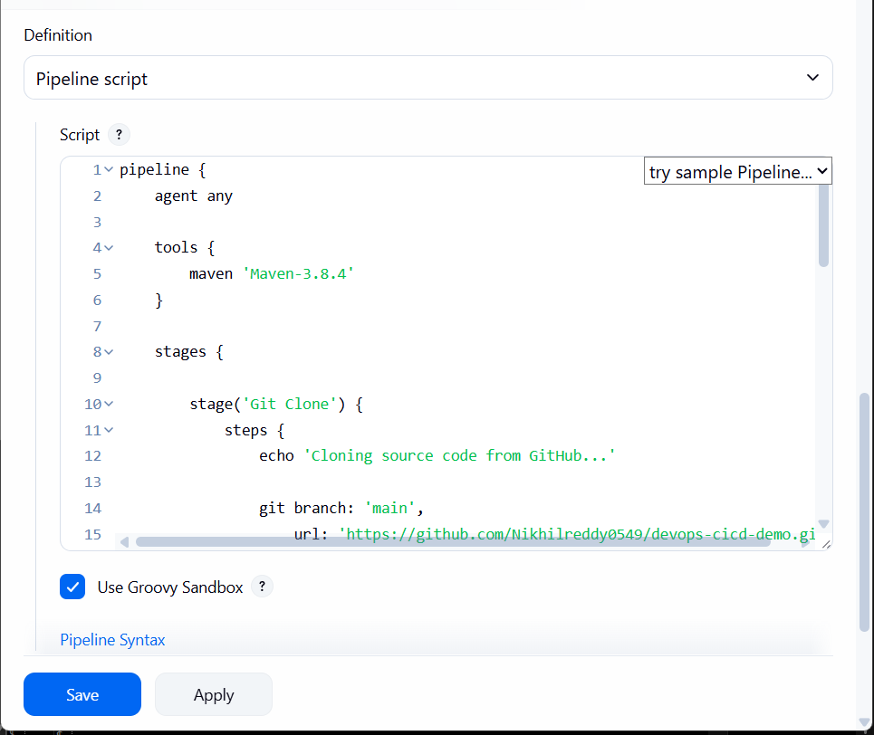

2.4 What each stage does

Stage 1 — Git Clone
stage('Git Clone')
Jenkins downloads the application source code from GitHub.
GitHub
↓
Jenkins Workspace

Stage 2 — Build
mvn clean compile
Maven:
- Deletes previous build output.
- Resolves dependencies.
- Compiles the Java source code.
Source Code
↓
Maven Compile
↓
.class files

Stage 3 — Test
mvn test
Jenkins executes the application's unit tests.
If tests fail:
Test Failure
↓
Jenkins Build FAILED
The later stages won't execute.

Stage 4 — Package
mvn package -DskipTests
This creates the application artifact.
For a Maven web application, you'll typically get:
target/application.war
For a normal Java application:
target/application.jar

2.5 Run the Jenkins job
Click:
Build Now
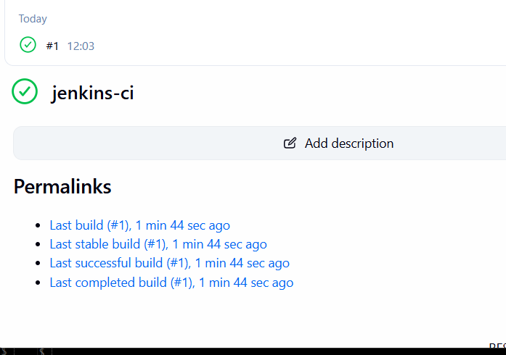
Then open:
Build #1
↓
Console Output
You should see something similar to:
[Pipeline] stage
[Pipeline] { (Git Clone)
...
[Pipeline] }

[Pipeline] stage
[Pipeline] { (Build)
...
BUILD SUCCESS
...

[Pipeline] stage
[Pipeline] { (Test)
...
Tests run: ...
Failures: 0
...

[Pipeline] stage
[Pipeline] { (Package)
...
BUILD SUCCESS
...
Finally:
Finished: SUCCESS
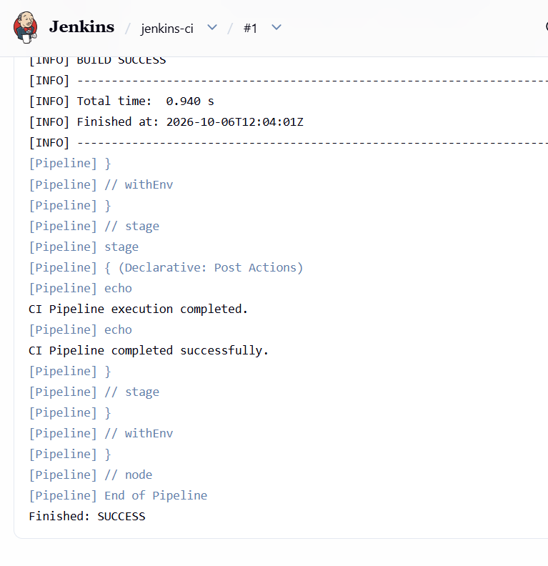

2.6 CI architecture
After Task 2, your pipeline is:
Developer
|
| git push
↓
GitHub
|
| clone
↓
+---------+
| Jenkins |
+---------+
|
+-------+-------+
| | |
↓ ↓ ↓
Build Test Package
| | |
+-------+-------+
|
↓
JAR / WAR

Task 2 outcome
You will have a Jenkins job called:
jenkins-ci
that performs:
Git Clone → Maven Build → Test → Package

Task 3 — Jenkins Docker Build & Push to Amazon ECR

Objective
Extend our Jenkins CI/CD process so Jenkins:
GitHub
↓
Jenkins
↓
Maven Build
↓
Docker Build
↓
Docker Image
↓
Amazon ECR
We'll use Amazon ECR because Task 4 will deploy that image to your EKS cluster.

Step 3.1 — Verify Docker and AWS CLI
On your Jenkins EC2 server, run:
docker --version
Then:
aws --version
Then verify AWS authentication:
aws sts get-caller-identity
And check your region:
aws configure get region

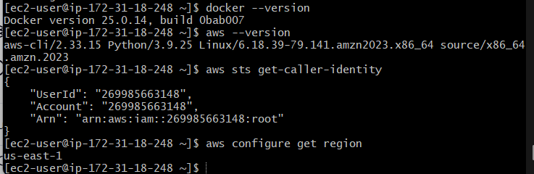

Step 3.2 — Create the ECR repository
We'll create an ECR repository for our application.
Run on the Jenkins server:
aws ecr create-repository \
--repository-name devops-cicd-demo \
--region us-east-1
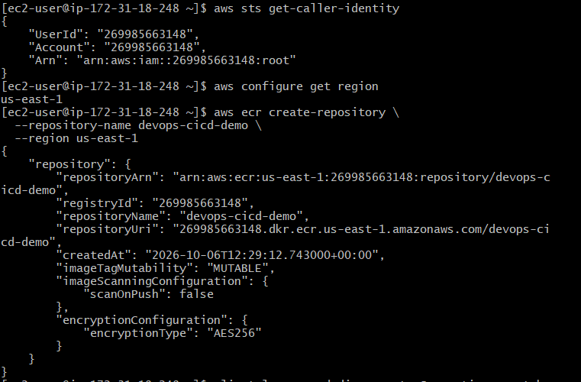
If it already exists, that's okay; you'll get a RepositoryAlreadyExistsException.
Then verify it:
aws ecr describe-repositories \
--repository-names devops-cicd-demo \
--region us-east-1
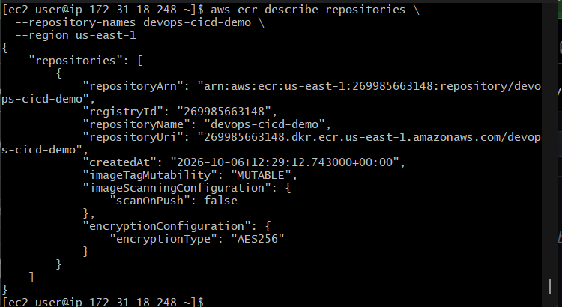
You should see something similar to:
repositoryName: devops-cicd-demo
repositoryUri: 269985663148.dkr.ecr.us-east-1.amazonaws.com/devops-cicd-demo

Step 3.3 — Create the Dockerfile
We'll package the JAR produced by Maven into a lightweight Java container.
On the Jenkins server:
cd ~/devops-cicd-demo
First check the JAR:
ls -lh target/
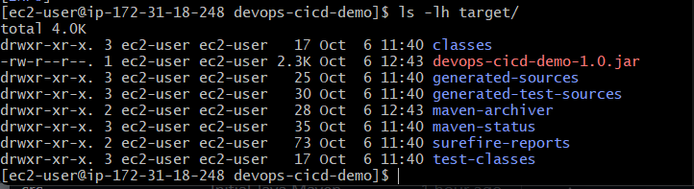
You should see:
devops-cicd-demo-1.0.jar
Now create the Dockerfile:
cat > Dockerfile <<'EOF'
FROM amazoncorretto:17-alpine

WORKDIR /app

COPY target/devops-cicd-demo-1.0.jar app.jar

EXPOSE 8080

CMD ["java", "-jar", "app.jar"]
EOF
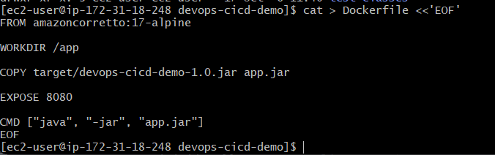

Why this Dockerfile?
Amazon Corretto 17
↓
/app directory
↓
Copy Maven JAR
↓
app.jar
↓
Java -jar app.jar

Step 3.4 — Build the Docker image manually
Before putting Docker into Jenkins, let's prove the image works.
Run:
docker build -t devops-cicd-demo:1.0 .
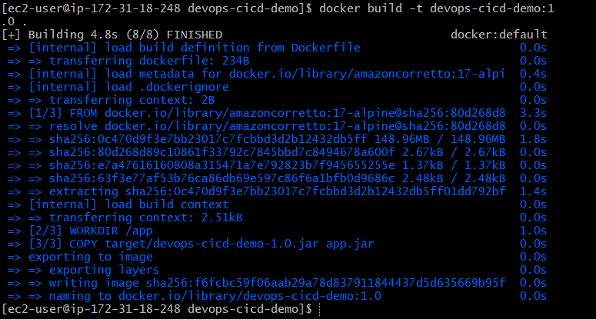
Then:
docker images | grep devops-cicd-demo
You should see something similar to:
devops-cicd-demo 1.0 <image-id> ...
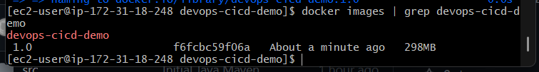

Step 3.5 — Test the Docker container
Run:
docker run --rm devops-cicd-demo:1.0
Expected output:
Hello from DevOps CI/CD Demo!
Because our Java application is a console application, the container will start, print the message, and exit. That's expected.

Step 3.6 — Verify Jenkins can use Docker and AWS
This is important because the commands worked as ec2-user, but the Jenkins pipeline normally runs as the jenkins user.
On the Jenkins EC2 server, run:
sudo -u jenkins docker --version
Then:
sudo -u jenkins aws –version
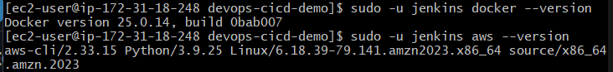
Then:
sudo -u jenkins aws sts get-caller-identity
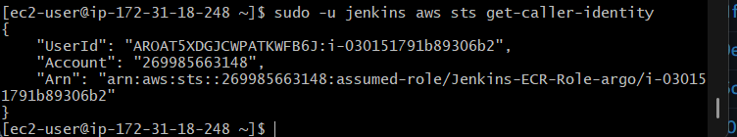
Finally check Docker access:
sudo -u jenkins docker ps

Step 3.7 — Push the Dockerfile to GitHub
The Jenkins pipeline will clone the repository from GitHub, so the Dockerfile must be there.
On the Jenkins server:
cd ~/devops-cicd-demo
Check:
ls -l Dockerfile pom.xml
Also create a .gitignore so Maven's generated target/ directory isn't stored in Git:
cat > .gitignore <<'EOF'
target/
*.log
EOF
Now check Git:
git status
You should see Dockerfile and .gitignore as untracked, and possibly other changes.
Add them:
git add Dockerfile .gitignore
Commit:
git commit -m "Add Docker configuration"
Push:
git push origin main
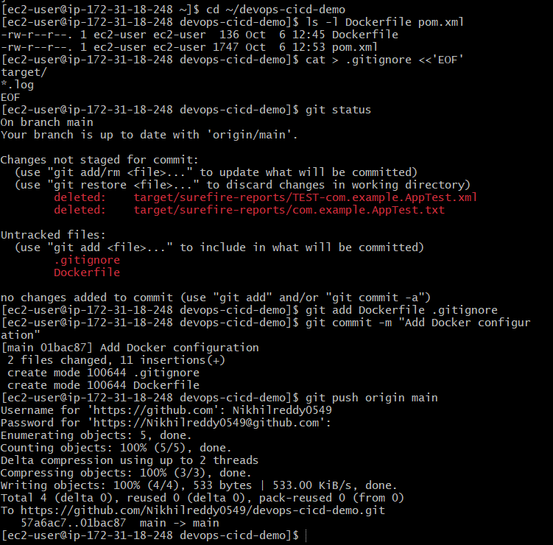

Step 3.8 — Verify GitHub contents
Your repository should now contain at least:
devops-cicd-demo/
├── .gitignore
├── Dockerfile
├── pom.xml
└── src/
├── main/
│ └── java/
│ └── com/example/App.java
└── test/
└── java/
└── com/example/AppTest.java
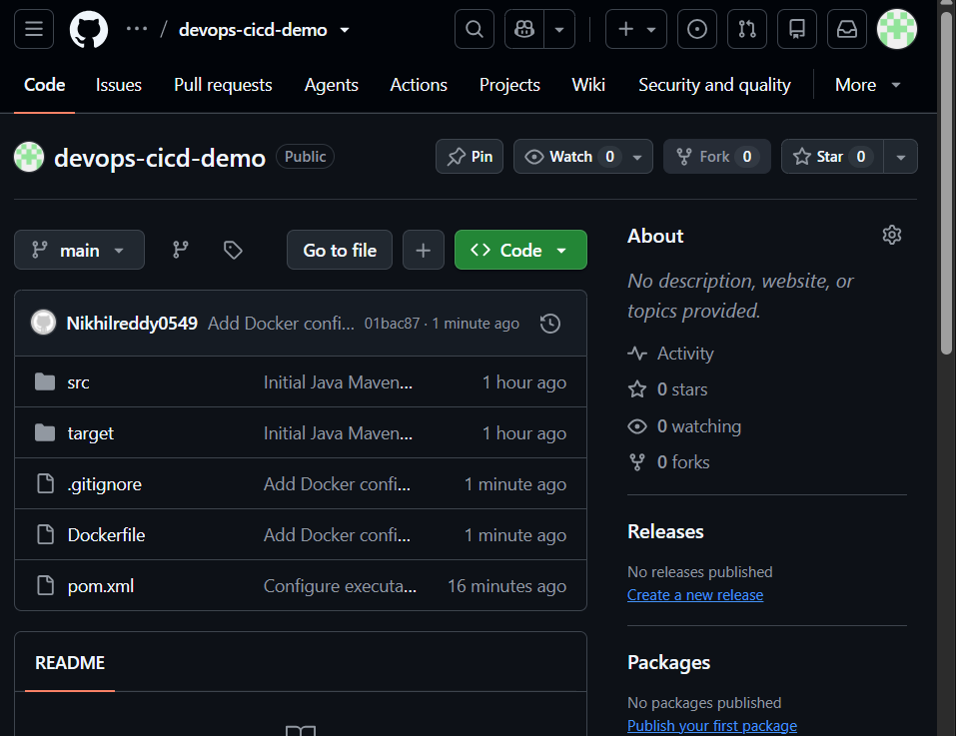
Once the push succeeds, we'll create the Jenkins pipeline:

Step 3.10 — Update the Jenkins pipeline
Go to:
Jenkins → jenkins-ci → Configure → Pipeline
We can extend the existing CI pipeline instead of creating another Jenkins job. This gives us one pipeline for CI + Docker image build/push.
Replace the current pipeline with:
pipeline {
agent any

environment {
AWS_REGION = 'us-east-1'
ECR_REPOSITORY = 'devops-cicd-demo'
AWS_ACCOUNT_ID = '269985663148'
IMAGE_TAG = "${BUILD_NUMBER}"
ECR_REGISTRY = "${AWS_ACCOUNT_ID}.dkr.ecr.${AWS_REGION}.amazonaws.com"
ECR_IMAGE = "${ECR_REGISTRY}/${ECR_REPOSITORY}:${IMAGE_TAG}"
}

tools {
maven 'Maven-3.8.4'
}

stages {

stage('Git Clone') {
steps {
echo 'Cloning source code from GitHub...'

git branch: 'main',
url: 'https://github.com/Nikhilreddy0549/devops-cicd-demo.git'
}
}

stage('Build') {
steps {
echo 'Compiling application...'
sh 'mvn clean compile'
}
}

stage('Test') {
steps {
echo 'Running unit tests...'
sh 'mvn test'
}
}

stage('Package') {
steps {
echo 'Creating JAR package...'
sh 'mvn package -DskipTests'
}
}

stage('Docker Build') {
steps {
echo "Building Docker image: ${ECR_IMAGE}"

sh '''
docker build \
-t ${ECR_IMAGE} \
.
'''
}
}

stage('ECR Login') {
steps {
echo 'Logging in to Amazon ECR...'

sh '''
aws ecr get-login-password --region ${AWS_REGION} |
docker login \
--username AWS \
--password-stdin ${ECR_REGISTRY}
'''
}
}

stage('Docker Push') {
steps {
echo "Pushing image to ECR: ${ECR_IMAGE}"

sh '''
docker push ${ECR_IMAGE}
'''
}
}
}

post {
success {
echo "CI/CD image pipeline completed successfully."
echo "Docker image: ${ECR_IMAGE}"
}

failure {
echo 'Pipeline failed.'
}

always {
echo 'Pipeline execution completed.'
}
}
}
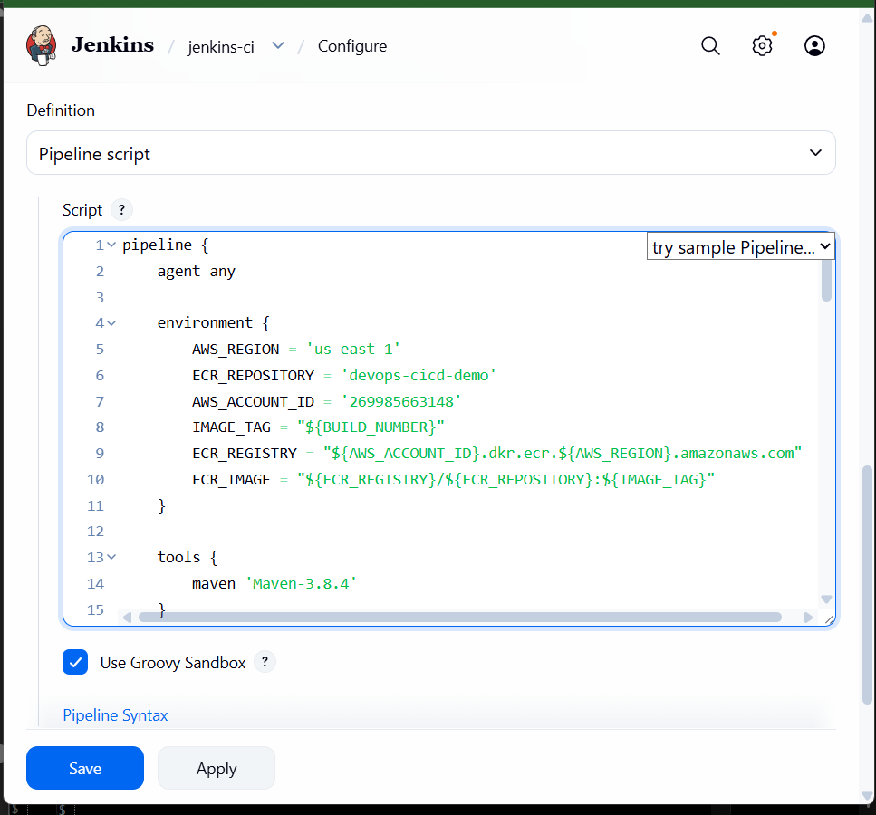

What changed?
Previously:
GitHub
↓
Build
↓
Test
↓
Package
Now:
GitHub
↓
Build
↓
Test
↓
Package
↓
Docker Build
↓
ECR Login
↓
Docker Push

Important: image tagging
We're using the Jenkins build number:
BUILD_NUMBER
So if this is Jenkins build #2, the image will be:
269985663148.dkr.ecr.us-east-1.amazonaws.com/devops-cicd-demo:2
If the next build is #3:
269985663148.dkr.ecr.us-east-1.amazonaws.com/devops-cicd-demo:3
This is better than continuously overwriting latest, because we can identify exactly which Jenkins build produced an image.

Save → Build Now
After pasting the pipeline:
Save → Build Now
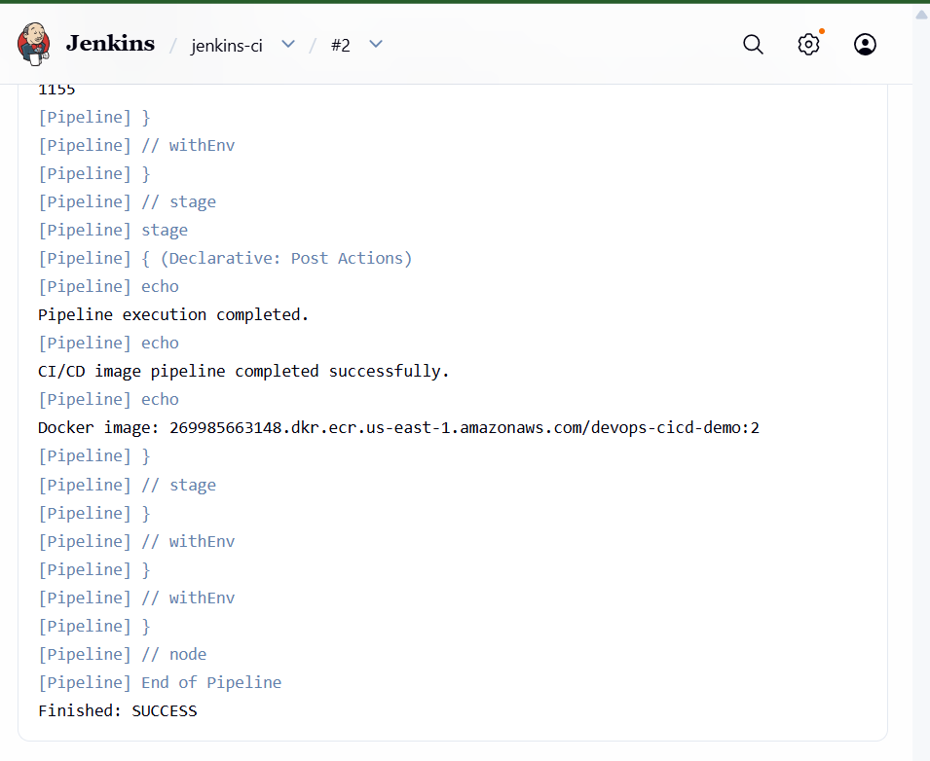
Watch the stages:
Git Clone ✅
Build ✅
Test ✅
Package ✅
Docker Build ✅
ECR Login ✅
Docker Push ✅

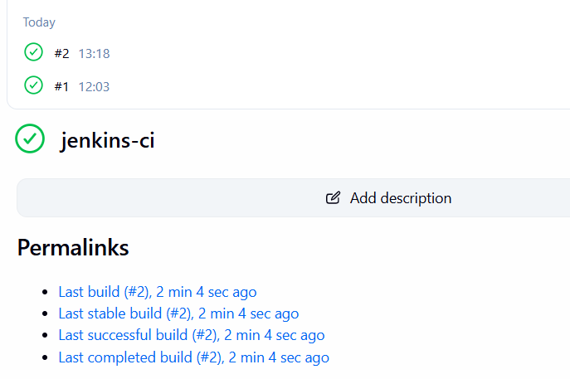

Verify the image in ECR
Run on the Jenkins server:
aws ecr describe-images \
--repository-name devops-cicd-demo \
--region us-east-1
You should see an image with a tag matching your Jenkins build number, for example:
imageTags: ["2"]

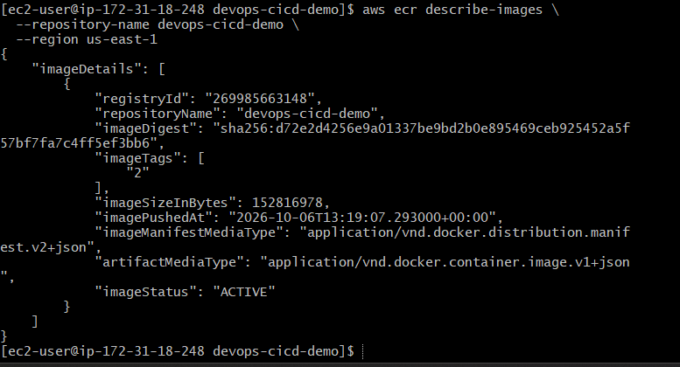

Task 4 — Argo CD Deployment to EKS

Objective
Deploy the Docker image produced by Jenkins and stored in ECR into your existing EKS cluster using Argo CD GitOps.
The final architecture will be:
Developer
|
v
GitHub
|
v
Jenkins
CI + Docker Build
|
v
Amazon ECR
|
| image
v
GitOps Repository
|
| Kubernetes manifests
v
Argo CD
|
v
EKS Cluster
|
v
Application

Important concept
We do not need Jenkins to directly run kubectl apply.
Instead:
Jenkins → updates GitOps repository
↓
Argo CD
↓
EKS
This is the GitOps approach.

Step 4.1 — Create a GitOps repository
Create another empty GitHub repository.
Use:
Repository name: devops-cicd-demo-gitops
Make it:
Public
Do not add:
- README
- .gitignore
- License
- 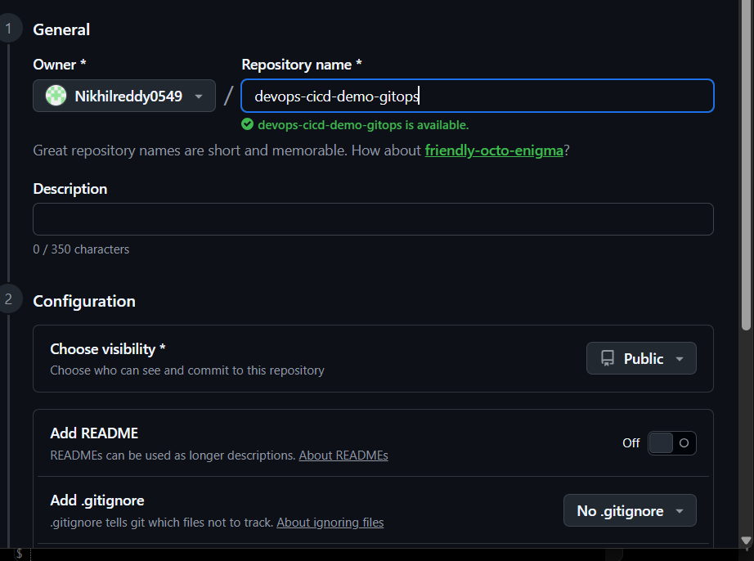
So you'll have two repositories:
1. devops-cicd-demo
└── Application source code

2. devops-cicd-demo-gitops
└── Kubernetes deployment manifests
The first repository is used by Jenkins.
The second repository is watched by Argo CD.

Why two repositories?
Application Repo
|
| Java source
v
Jenkins
|
| Docker image
v
ECR

GitOps Repo
|
| Kubernetes YAML
v
Argo CD
|
v
EKS
This separation is common in GitOps implementations.

Step 4.2 — Create Kubernetes manifests
We'll create two Kubernetes resources:
- Deployment — runs our application container.
- Service — exposes the application inside the EKS cluster.
We'll use the ECR image that Jenkins pushed.
For the first deployment, let's use the image tag from the successful Jenkins build. If your successful Task 3 build was #2, the image is:
269985663148.dkr.ecr.us-east-1.amazonaws.com/devops-cicd-demo:2
If your build number was different, replace 2 with that build number.

On your Jenkins server
Create the GitOps directory:
mkdir -p ~/devops-cicd-demo-gitops
cd ~/devops-cicd-demo-gitops

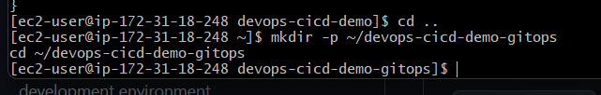
Create deployment.yaml:
cat > deployment.yaml <<'EOF'
apiVersion: apps/v1
kind: Deployment
metadata:
name: devops-cicd-demo
namespace: devops-demo
spec:
replicas: 2
selector:
matchLabels:
app: devops-cicd-demo
template:
metadata:
labels:
app: devops-cicd-demo
spec:
containers:
- name: devops-cicd-demo
image: 269985663148.dkr.ecr.us-east-1.amazonaws.com/devops-cicd-demo:2
ports:
- containerPort: 8080
imagePullPolicy: Always
EOF
Create service.yaml:
cat > service.yaml <<'EOF'
apiVersion: v1
kind: Service
metadata:
name: devops-cicd-demo
namespace: devops-demo
spec:
selector:
app: devops-cicd-demo
ports:
- protocol: TCP
port: 80
targetPort: 8080
type: ClusterIP
EOF
Create namespace.yaml:
cat > namespace.yaml <<'EOF'
apiVersion: v1
kind: Namespace
metadata:
name: devops-demo
EOF
Your GitOps repository should now contain:
devops-cicd-demo-gitops/
├── namespace.yaml
├── deployment.yaml
└── service.yaml
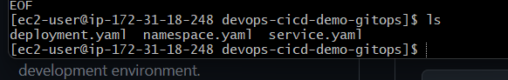

Step 4.3 — Push the GitOps repository
Initialize Git:
git init
git branch -M main
Configure identity if needed:
git config user.name "Nikhilreddy0549"
git config user.email "YOUR_GITHUB_EMAIL"
Add the files:
git add .
Commit:
git commit -m "Add EKS deployment manifests"
Add your GitHub GitOps repository:
git remote add origin https://github.com/Nikhilreddy0549/devops-cicd-demo-gitops.git
Push:
git push -u origin main
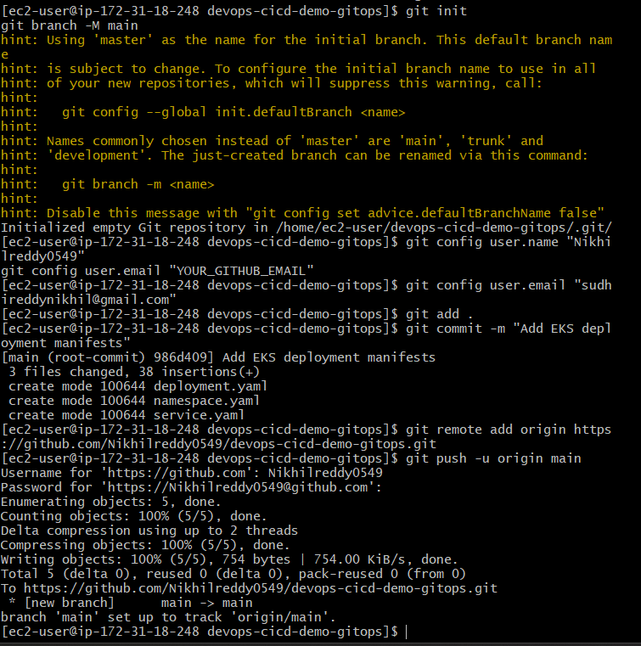

Step 4.4 — Create the Argo CD Application
Now we'll tell Argo CD:
Watch this GitHub repository and deploy its Kubernetes manifests to my EKS cluster.

1. Verify you're connected to the EKS cluster
On the machine where you have kubectl and Argo CD CLI configured, run:
kubectl config current-context
Then:
kubectl get nodes
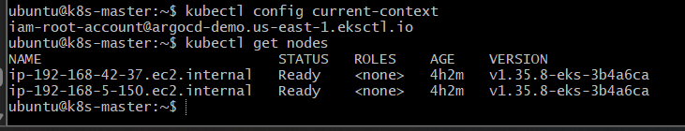
You should see your two EKS nodes in Ready state.
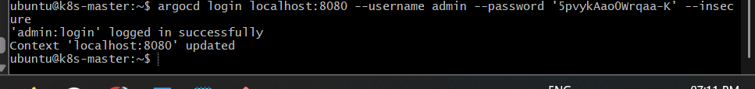

2. Create the Argo CD Application
Run:
argocd app create devops-cicd-demo \
--repo https://github.com/Nikhilreddy0549/devops-cicd-demo-gitops.git \
--revision main \
--path . \
--dest-server https://kubernetes.default.svc \
--dest-namespace devops-demo \
--directory-recurse
The important parts are:
GitOps repository
↓
devops-cicd-demo-gitops
↓
path: .
↓
Argo CD
↓
EKS cluster
↓
namespace: devops-demo
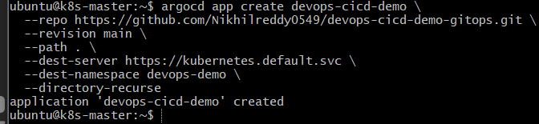

3. Check the Application
Run:
argocd app get devops-cicd-demo
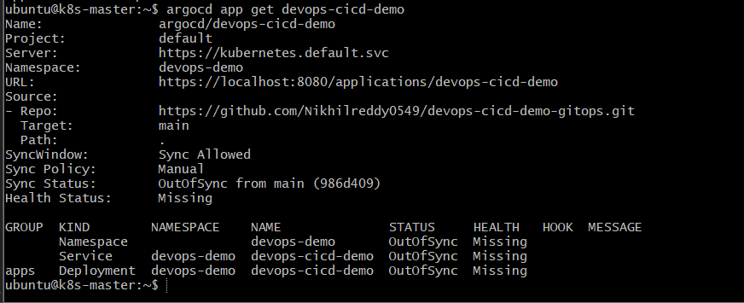
Initially you may see:
Sync Status: OutOfSync
Health Status: Missing
That's normal because we've created the Argo CD Application but haven't synchronized it yet.

4. Synchronize
Run:
argocd app sync devops-cicd-demo
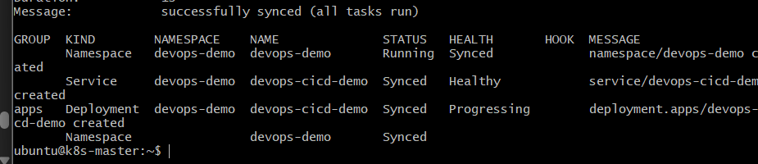
Then:
argocd app get devops-cicd-demo
We want:
Sync Status: Synced
Health Status: Healthy
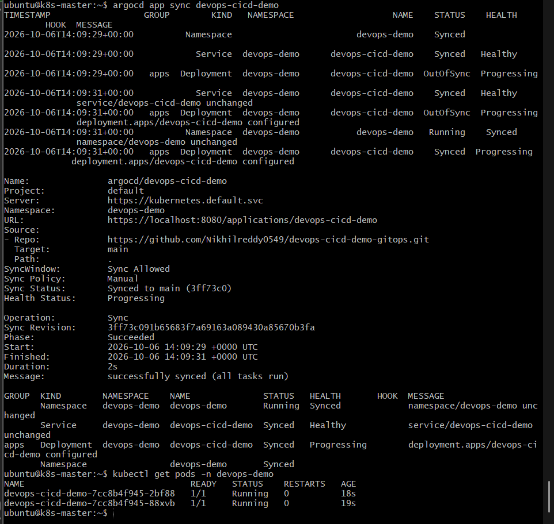

5. Verify on EKS
kubectl get pods -n devops-demo
Expected:
NAME READY STATUS RESTARTS
devops-cicd-demo-xxxxxxxxxx-xxxxx 1/1 Running 0
devops-cicd-demo-xxxxxxxxxx-xxxxx 1/1 Running 0
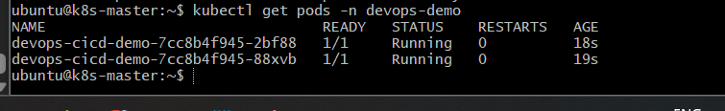
Also:
kubectl get deployment -n devops-demo
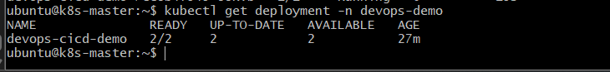
and:
kubectl get svc -n devops-demo

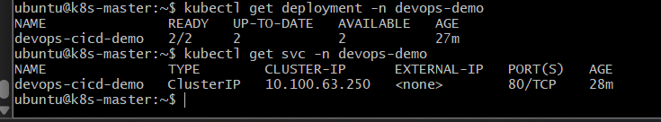

Test the Kubernetes Service
Run:
kubectl run test-client \
-n devops-demo \
--image=curlimages/curl \
--restart=Never \
--command -- curl -v http://devops-cicd-demo
Then check:
kubectl get pod test-client -n devops-demo
If the curl request succeeds, you should see:
Hello from DevOps CI/CD Demo!

